ALBERT LEA HOUSING AND REDEVELOPMENT AUTHORITY

ADMISSIONS AND CONTINUED OCCUPANCY POLICY

FOR THE

PUBLIC HOUSING PROGRAM

Product # 301-001

May 1, 2005

Revision Date
February 1, 2006 | March 1, 2016
October 1, 2006 | March 1, 2017
June 1, 2007 | July 1, 2017
September 1, 2008 | July 1, 2018
September 1, 2009 | November 12, 2019
August 1, 2010 | December 21, 2021
June 1, 2011 | October 28, 2025
June 1, 2012
June 1, 2013
July 1, 2014
June 1, 2015
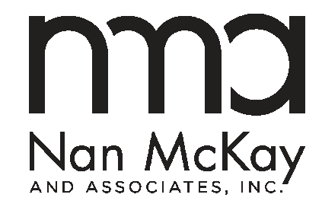
1810 Gillespie Way, Suite 202
El Cajon, CA 92020
800.783.3100
www.nanmckay.com

Copyright 2024 by Nan McKay & Associates, Inc.

All rights reserved

Permission to reprint granted only to the Public Housing Authority that has purchased this plan from Nan McKay & Associates, Inc. This document may not be reprinted or distributed to any other person or entity other than the purchasing agency without the express written permission of Nan McKay & Associates, Inc.

